Name: Amol Shivaji Tambekar Roll No:54 Batch:3
Step 1: Create Table and Sequence
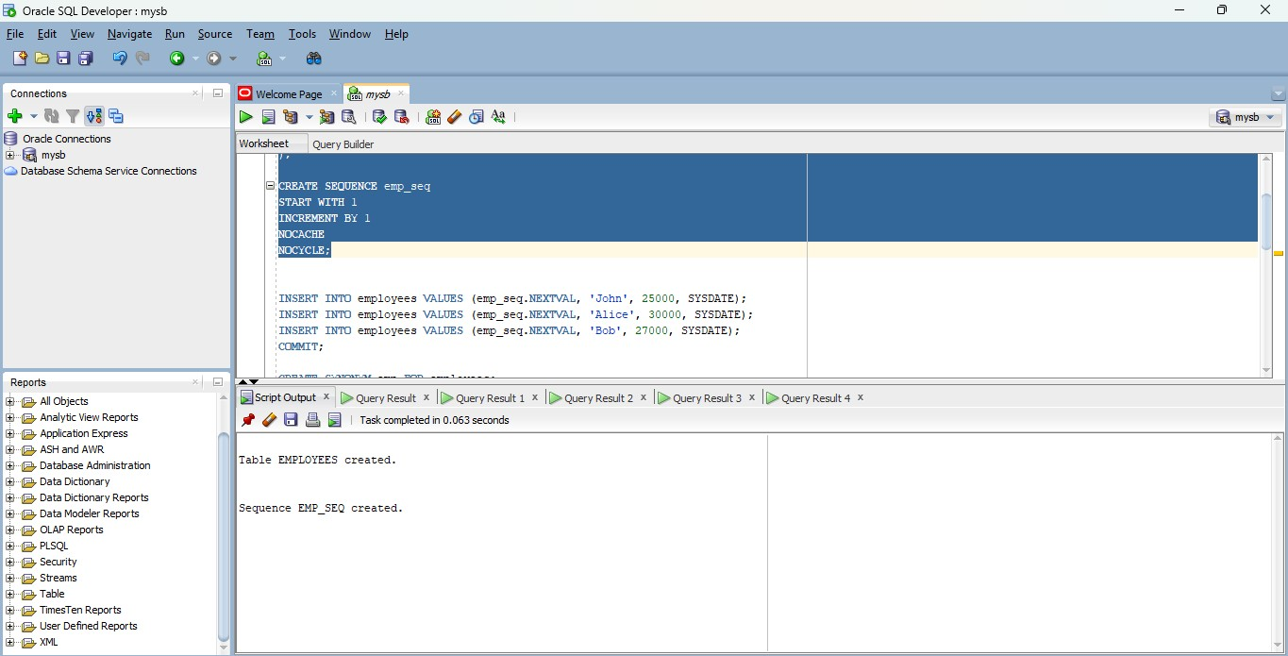

Step 2: Insert Data and Create Synonym
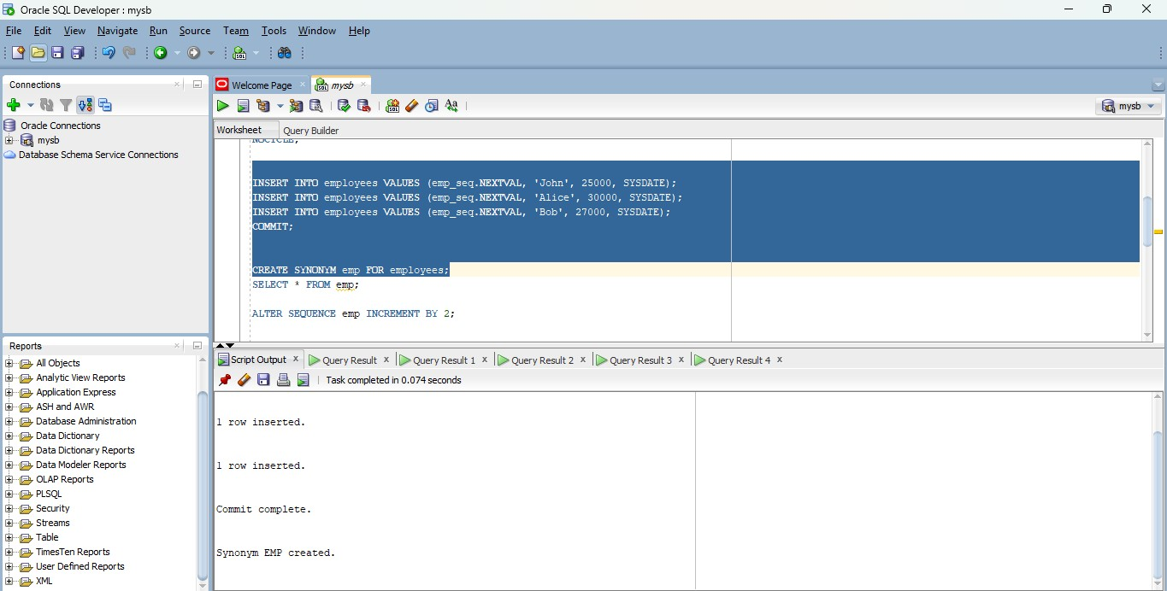

Step 3: Show Table
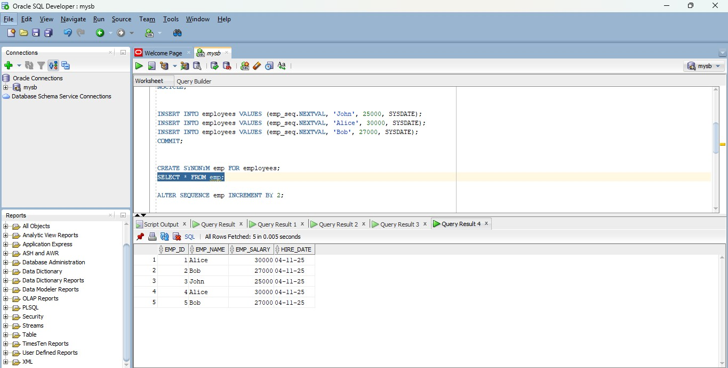

Step 4: Alter the Sequence
